October 14, 2022   
Rocio Chavela Guerra, PhD  
Jeffrey Stransky, MSc  
Steven Royek  
Engineering Hall 140,  
201 Mullica Hill Road  
[chavelaguerra@rowan.edu](mailto:chavelaguerra@rowan.edu)

Dear Dr. Chavela Guerra, Mr. Stransky, and Prof. Royek,

Through a three variable parametric design process, the initial bottle rocket was able to be optimized to maximize flight distance. Nose cone mass, water volume, and tailfin shape were varied independently of one another to measure their individual contributions to distance traveled. Through this parametric approach, a well-rounded data set was produced. Through a convergent process, the rocket design was able to be further improved to identify a local maximum of optimal design parameters.

Kevin Hack

Lab Portion: Data analysis, experiment design

Report: Analysis & discussion

Aidan Sharpe

Lab Portion: Rocket builder, experiment designer, launches coordinator, lead report editor, report formatting, report figures and tables.

Report: Methods & equations

Tyler Torres

Lab portion: Data acquisition, rocket builder, experiment designer.  
Report: Introduction, materials

Raaha Kumaresan  
Lab portion: Data acquisition, rocket builder  
Report: Introduction

If any questions or concerns arise, please contact one of the team members listed below and we will be happy to reply with further information.

Sincerely,

Aidan Sharpe Kevin Hack Tyler Torres Rahaa Kumaresan

https://lh6.googleusercontent.com/Qxfg5uQPIkf6pBqM0kU2Rc5ldoH1dtlBV0BMcv6efee5NJM24HET37lANHxuwsEErGOMKko4O4OUdJwRvfOQIe9xhqIuwzuhWN2rcq7oImo7OBMXyxz8XcxqxGvSVMh5aG16fir1XdpxqBc5g0avXEPv3ez5uFc4qTtanA90A8xMxcU790hHAcuDPQ

Bottle Rocket Optimization with

Parametric Design

Aidan Sharpe, Kevin Hack, Tyler Torres, Raaha Kumaresan

Sophomore Engineering Clinic I

Professor Chavela Guerra, Professor Stransky, Professor Royek

14 October 2022

# ABSTRACT

The purpose of this lab was to design and build a 2-liter bottle rocket that was optimized for distance traveled. The variables under test were clay nose cone mass, water propellant volume, and fin shape, all of which were optimized through a process of parametric variation. Data regarding rocket mass, air pressure, and initial launch angle were recorded in addition to the test variables. The measured variable was distance in the initial launch direction, meaning all deviations from the initial direction reduced the overall performance of a given set of design parameters. Through these tests, water volume was optimal at about 470mL and nose cone mass at around 130g. Additionally, it was found that larger fins devastated performance when compared to smaller, lower-profile fins. By combining the best of the three variables, the most optimal bottle rocket should be achieved.

# INTRODUCTION

Since 1973, water bottle rockets have been used in classrooms to teach students the basic principles of aerodynamics and the engineering design process. Research typically consists of learning basic aerodynamic physics, understanding previous successful bottle rocket models, and most importantly, running experiments.

Similar to chemical rockets, a thrust force is exerted to propel it forward, and the primary physical mechanism is Newton’s third law of motion. Since there is a force that is moving the water out of the bottle, an equal and opposite force is acting on the bottle which allows it to fly.

However, unlike chemical rockets, the energy in a bottle rocket comes from the difference in pressure between the inside and outside of the container.

Using this physics background and divergent thinking, every member in the group applied their knowledge from researching to possible modifications to the bottle rocket that would improve its flight length. Due to time constraints, it was advised that we select only three variables for parametric testing. The scope of our testing included adjusting clay mass, volume of water, and fin shape to increase distance traveled. Initial pressure, initial flight angle, fin number, and fin location were all kept constant. In the end, convergent thinking was used to analyze and evaluate the performance of each combination of design variables.

# EXPERIMENTAL METHODS

All iterations of the bottle rocket were constructed using the same set of materials. In transitioning from one variable set to another, materials were added, removed, or modified. The following is a cumulative list of all materials required.

#### Table 1. List of materials for bottle rocket construction.

|  |  |
| --- | --- |
| Component | Materials Required |
| Nose cone | * (1) Sheet of A4 construction paper * 165g of modeling clay |
| Fins | * 500mm by 250mm sheet of cardboard * 3m by 250mm duct tape |
| Fuselage | * (1) 2L Coca-Cola® Bottle |

The design process began with a simple brainstorm. First, a simple nose cone was constructed with a crumpled sheet of paper covered with 137 g of clay. Then, three evenly spaced, duct tape-covered cardboard fins were made into a low-profile shape as seen in *Figure 1*. Each object’s mass was measured using a digital scale. After attaching the nose cone and fins to the 2L bottle, the parametric design process began.

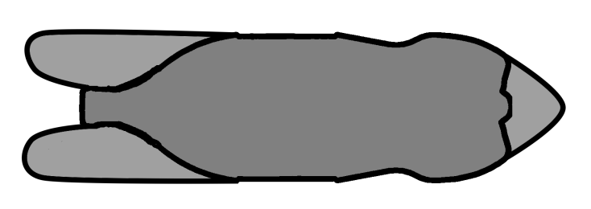

#### Figure 1. Initial fin and nose cone shape.

The first design variable to be manipulated and optimized was the water volume. Through research, it was determined that the amount of potential energy in the bottle is dependent only on volume and pressure, and that potential energy is proportional to distance traveled. As a result, the optimal volume of water for one design would be the optimal amount for all bottle rockets with the same internal volume and nozzle diameter.

The optimal water volume was determined through a two-step process. First, three data points were recorded. Each followed a functional format with an input water volume and an output distance traveled as seen in *Table 2*. Three points were collected to provide a decent dataset resolution while not consuming too much time.

#### Table 2. Water volume tests.

|  |  |
| --- | --- |
| Water Volume | Distance Traveled |
| 200mL | 43.28m |
| 400mL | 50.60m |
| 600mL | 49.56m |

Additionally, a quadratic power series approximation can be created with three data points. As seen in *Figure 2*, a quadratic power series approximation can be impressively accurate around the points sampled.

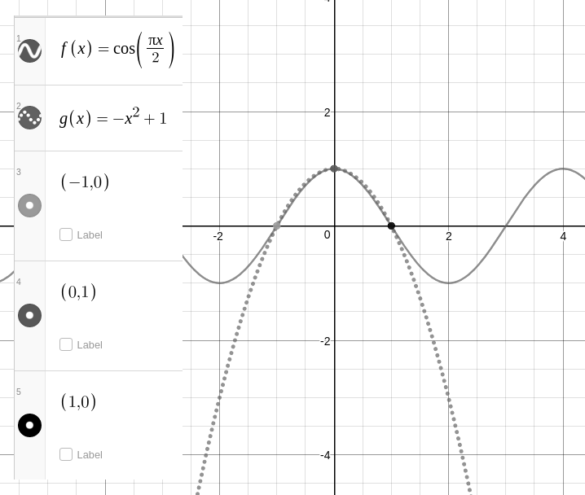

#### Figure 2. Quadratic power series approximation of a cosine function.

Given the standard form of a quadratic function as shown in *Equation 1*, the approximate function for distance versus water volume required solving for the quantities: *a*, *b*, and *c*.

$f\left(x\right)=ax^{2}+bx+c$ (1)

By plugging in water volume for *x* and distance for *y* it was possible to solve for the *a*, *b*, and *c* coefficients using *Equation 2*.

$\left[\begin{matrix}{x_{1}}^{2} & x_{1} & 1 \\ {x_{2}}^{2} & x_{2} & 1 \\ {x_{3}}^{2} & x_{3} & 1\end{matrix}\right]\left[\begin{matrix}a \\ b \\ c\end{matrix}\right]=\left[\begin{matrix}y_{1} \\ y_{2} \\ y_{3}\end{matrix}\right]$ (2)

The quadratic approximation was then analyzed for local maxima using *Equation 3.*

$x_{max}=\frac{-b}{2a}$ (3)

Through this process, it was determined that the optimal water volume was about 470mL.

After finding the most favorable amount of water, the next variable optimized was tailfin shape. Since low-profile fins were already installed, the first test of this parameter had the original tailfins and nose cone. For the remaining tests, water volume was held constant at 470mL. As seen in *Figure 3*, wide and long tailfins were also tested.

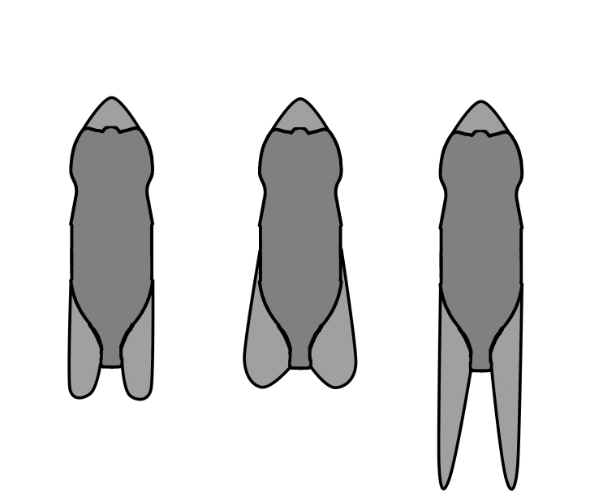

#### Figure 3. Tested bottle rocket fin designs.

After testing each of the three tailfin designs, the data recorded in *Table* 3 indicated that the original design was clearly the best.

#### Table 3. Fin shape effects on distance.

|  |  |
| --- | --- |
| Fin Shape Description | Distance Traveled |
| Low-profile | 58.82m |
| Wide | 44.32m |
| Long | 44.50m |

After determining the best fin shape to be low-profile, the nose cone design was manipulated and optimized. The first design that was tested had 124.7g of clay. It yielded a distance of 48.77m. Since this was a lesser distance than that achieved with the original 137g, the mass of clay was increased to 165.3 g, both of which yielded distances less than that achieved with 137g. Using a similar process to calculate the optimal volume of water, the optimal mass of clay was determined to be about 150g.

#### Table 4. Nose cone mass effects on distance.

|  |  |
| --- | --- |
| Nose cone Mass | Distance Traveled |
| 124.7g | 48.77m |
| 137g | 58.83m |
| 165.3g | 55.78m |

# RESULTS

As seen in *Figure* 4, by creating a quadratic model of the data on the volume of water and finding its maximum, the optimal volume of water was approximated to be 475.12mL.

#### 

#### Figure 4. Quadratic model of distance vs. volume of water.

Similarly, as seen in *Figure 5*, a quadratic model of the nose cone mass data also predicts the optimal quantity. In this case, the approximated optimal clay mass is ~147.8g.

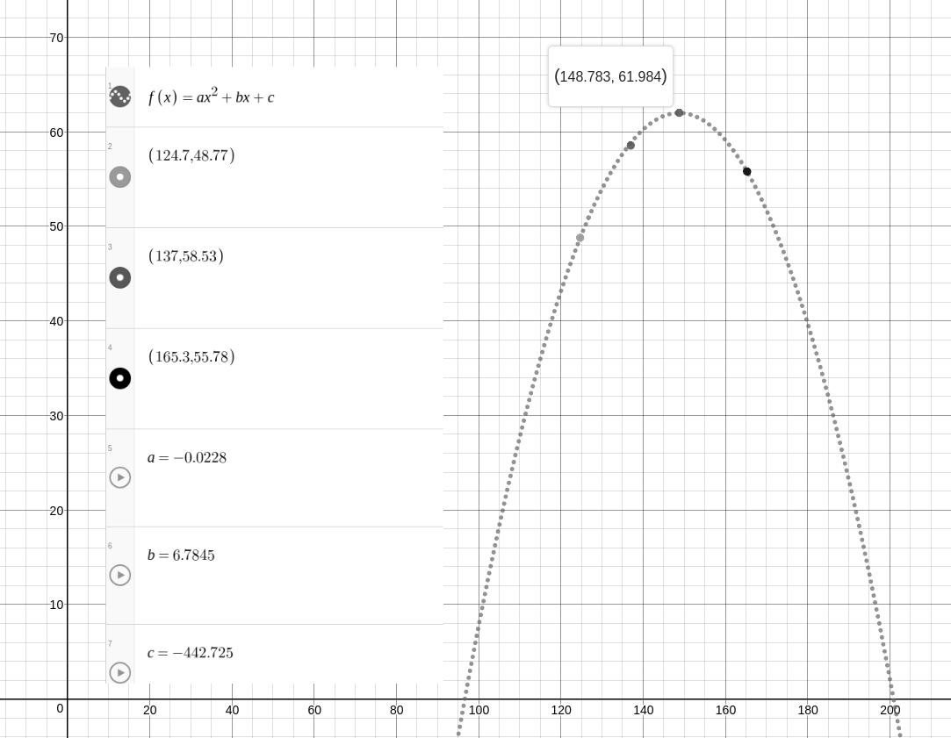

#### Figure 5. Quadratic model of distance vs. nose cone mass.

Additionally, as demonstrated by *Figure* 6, the data recorded on different fin shapes indicated that the smaller fins were the best.

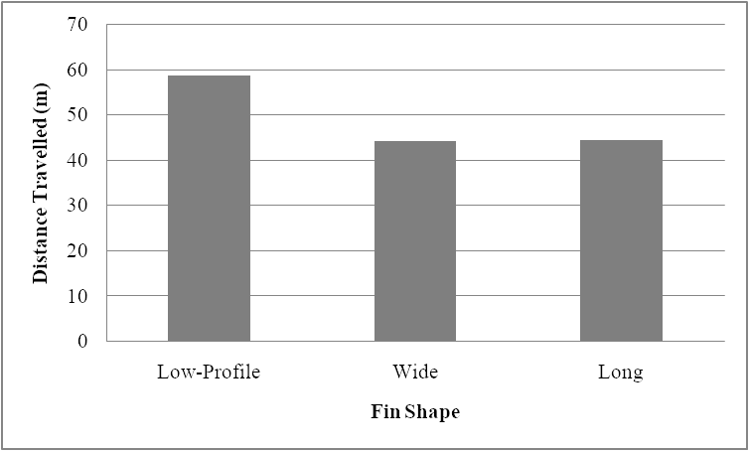

#### Figure 6. Effectiveness of fin designs.

# ANALYSIS & DISCUSSION

The original rocket performed well, and definitely exceeded expectations. After performing three successful launch tests on the first day, it was determined that 470mL was the approximately the optimal amount of water. Therefore, this volume was kept constant for the remaining experiments. After a series of misfires during the second launch testing day, the third experimental trial was able to successfully test a wide and long variant of wings. After several tests, the data indicated that the original fin design was the best of set. Since both the wide and long wings are larger, they are likely to generate more drag than the smaller, low-profile wings. This increased drag is a strong contender for their decreased performance. The fourth testing session involved making adjustments to the nose cone mass. Data was collected on three nose cone masses: 125g, 137g, and 165g. Through data analysis, it was determined that the optimal mass resided around 150g.

Additionally, the quadratic model created on nose cone data provided further insight as to why some mass was better than none at all. Since the parabolic model goes negative at a little under 100g, it is reasonable to predict that the mass acts to balance the rocket.

Although the original design fared quite well, higher data resolution would have allowed for better models to be constructed. Additional testing would have allowed errors to become more negligible, resulting in higher certainty on predictions.

Due to time constraints, the bottle rocket had to be optimized from a single initial condition. If more time were to be allotted for testing, a much wider set of rocket designs could have been tested. Overall, the set of tests completed provided enough data to converge on an optimal iteration of the initial design.

# APPENDIX

### Mathematical Models

Mathematical models were used to predict the distance traveled by the rocket given ideal conditions. All variables in this section are consistently labeled and the calculations are cumulative. All subsequent equations can be rewritten in terms of water volume instead of gas volume using *Equation 4.*

$V_{i}=V_{f}-V_{w}$ (4)

Where:

$V_{w}$ is the initial volume of water in the container, $V_{f}$ is the volume of the container, and $V_{i}$ is the initial volume of gas in the container.

The work done by the rocket is described by *Equation 5*. The resultant work done was about 127J.

# $W=P_{i}V_{i}\ln\left(\frac{V_{f}}{V_{i}}\right)$ (5)

Where:

$P_{i}$ is the initial pressure.

The total mass of the rocket at launch is described by *Equation 6*. Given 700mL of water, the net mass of the bottle rocket was 563.3g.

$m=\frac{ρ_{w}V_{w}}{2}+m_{r}$ (6)

Where:

$ρ_{w}$ is the density of water, and $m_{r}$ is the mass of the empty bottle rocket.

During a launch, the maximum height of the rocket is modeled by *Equation 7*. From the above equations, it was calculated that the maximum height was 23.01m.

$h=\frac{W}{mg}$ ­ (7)

Where:

$g$ is gravitational acceleration.

The initial speed of the rocket is calculated using *Equation 8*. Since the launch area was fairly level, the initial height can be assumed to be 0m. Therefore, the initial speed of the rocket is 21.23m/s.

$v_{i}=\sqrt{2\left(\frac{W}{m}-gh_{0}\right)}$ (8)

Where:

$h_{0}$ is the initial height of the rocket.

Finally, the distance traveled by the bottle rocket can be modeled by *Equation 9*. The launch angle was always 45°, or $\frac{π}{4}$ radians. Therefore, ignoring air resistance, the distance traveled is 46.0m.

$d=\frac{{v_{i}}^{2}\sin\left(2θ\right)}{g}$ (9)

Where:

$θ$ is the launch angle with respect to the ground.

### Sensor Data

For one test, the bottle was equipped with a sensor to measure height over time. During this test, the bottle was filled with 700mL of water. The data recorded by the sensor is shown in *Figure 7*.

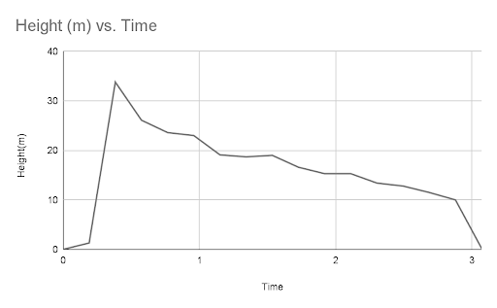

#### Figure 7. Bottle rocket height vs. time in sensor test.

# REFRENCES

de Podesta, M. (2006). *A guide to building and understanding the physics of*. <https://www.npl.co.uk/skills-learning/outreach/water-rockets/wr_booklet_print>

Domun, Y. (2016, June 10). *Aerodynamics Basics - Know the fundamentals*. EngineeringClicks. <https://www.engineeringclicks.com/aerodynamics-basics/>

Dutta, P. (2017, December 14). *How to Make a Water Bottle Rocket | Science Project Ideas*. Science Fair Projects. <https://www.scienceprojectideas.org/water-bottle-rocket.htm>

May, S. (2011, June 4). *What Is Aerodynamics?* NASA; NASA. <https://www.nasa.gov/audience/forstudents/k-4/stories/nasa-knows/what-is-aerodynamics-k4.html>

Mazza, D. (2014). *Water Rocketry - About Bottle Rockets*. Nasa.gov. <https://www.grc.nasa.gov/WWW/k-12/rocket/BottleRocket/about.htm>

Watts, G. (2022, March 24). *How Rockets Work: A Complete Guide - Wired Cosmos*. Wiredcosmos.com. <https://wiredcosmos.com/how-rockets-work-a-complete-guide/#:~:text=How%20Do%20Rockets%20Work%3F%20Rockets%20use%20momentum%20to>